Abstract—These instructions give you guidelines for preparing papers for the 7th Spanish Conference on Electronic Devices to be held in Santiago de Compostela (Spain) from Feb 11th to Feb 13th 2009. Use this document as a template if you are using Microsoft Word 6.0 or later. Otherwise, use this document as an instruction set. The electronic file of your paper will NOT be formatted further at IEEE. Define all symbols used in the abstract. Do not cite references in the abstract. Do not delete the blank line immediately above the abstract; it sets author box at its adequate position.
Preparation of Papers for the
7th Spanish Conference on Electronic Devices
First A. Author, Second B. Author, Jr., and Third C. Author, Member, IEEE
Authors’ Affiliations

INTRODUCTION
This document is a template for Microsoft Word versions 6.0 or later. If you are reading a paper version of this document, please download the electronic file, from http://www.ac.usc.es/cde09/paper_submission so you can use it to prepare your manuscript.
Do not change the font sizes or line spacing to squeeze more text into a limited number of pages. Use italics for emphasis; do not underline.
To insert images in Word, position the cursor at the insertion point and either use Insert | Picture | From File or copy the image to the Windows clipboard and then Edit | Paste Special | Picture (with “Float over text” unchecked).
IEEE will do the final formatting of your paper. If your paper is intended for a conference, please observe the conference page limits.

Procedure for Paper Submission

Final Stage
First of all, check that your PDF file is IEEEXplore compliant using IEEE PDF eXpress. You also can generate it using PDF eXpress from your source files (LaTeX or Word files). It is very important to meet the IEEE PDF requirements. If not, the paper might be not included in the Conference Proceedings. To connect to IEEE PDF eXpress use this link, http://www.pdf-express.org/ and follow the instructions below:
- Click on the link "New Users - Click Here" and fill in your information. You will need the Conference ID which is: cde09x
- Frequently asked questions about IEEE Xplore compliant PDF files can be found in http://www.ieee.org/portal/pages/pubs/confstandards/faq.html

Copyright Form
An IEEE copyright form should accompany your final submission. You can get a .pdf, .html, or .doc version at http://www.ieee.org/copyright or from the first issues in each volume of the IEEE TRANSACTIONS and JOURNALS. Authors are responsible for obtaining any security clearances.

MATH
If you are using Word, use either the Microsoft Equation Editor or the MathType add-on (http://www.mathtype.com) for equations in your paper (Insert | Object | Create New | Microsoft Equation or MathType Equation). “Float over text” should not be selected.

Units
Use either SI (MKS) or CGS as primary units. (SI units are strongly encouraged.) English units may be used as secondary units (in parentheses). An exception is when English units are used as identifiers in trade, such as “3½ in disk drive.” Avoid combining SI and CGS units, such as current in amperes and magnetic field in oersteds. This often leads to confusion because equations do not balance dimensionally. If you must use mixed units, clearly state the units for each quantity in an equation.

Helpful Hints

Sections and subsections
Section headers will be numbered with Roman numerals with the paragraph centered. Subsections (if any) will be numbered with capital letters as in this template.
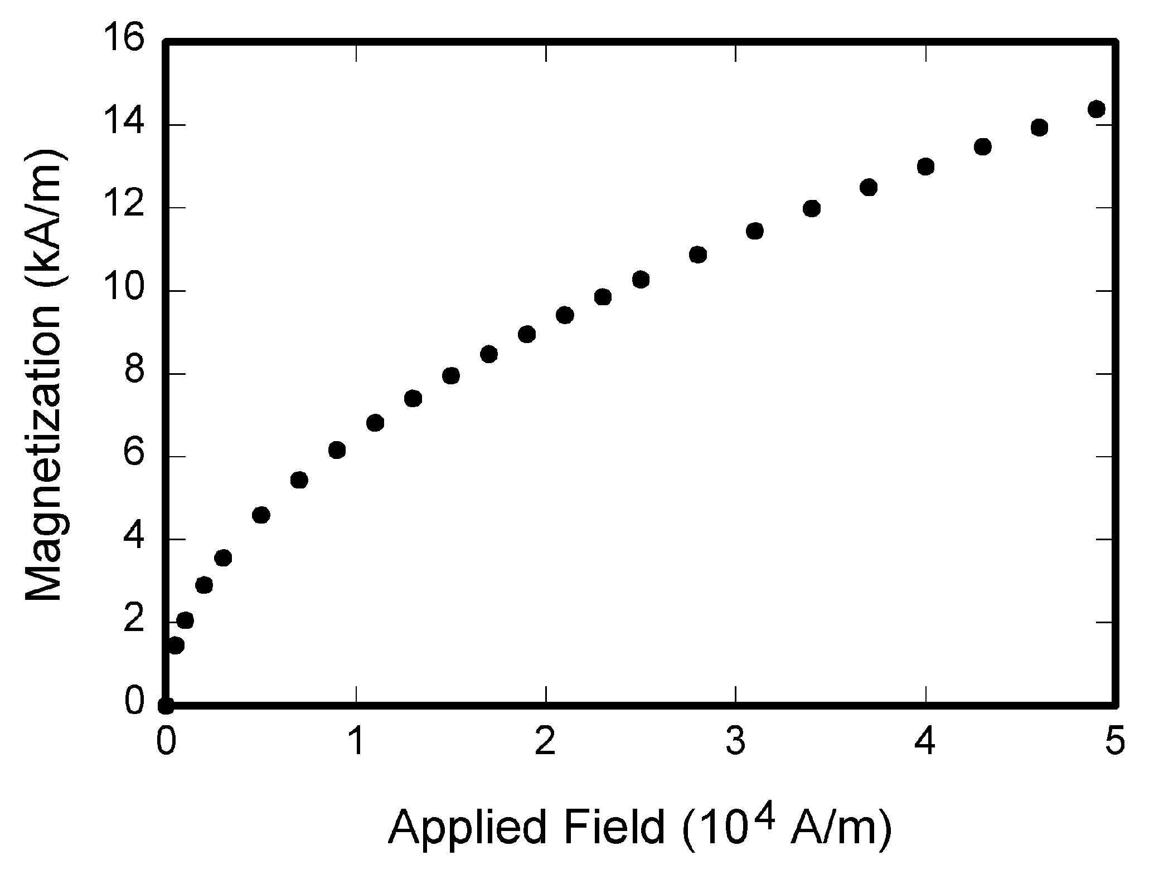
Fig. 1. Magnetization as a function of applied field. Note that “Fig.” is abbreviated. There is a period after the figure number, followed by two spaces. It is good practice to explain the significance of the figure in the caption.

Figures and Tables
Because IEEE will NOT do the final formatting of your paper, you need to position figures and tables at the top and bottom of each column. Large figures and tables may span both columns. Place figure captions below the figures; place table titles above the tables. If your figure has two parts, include the labels “(a)” and “(b)” as part of the artwork. Please verify that the figures and tables you mention in the text actually exist. Please do not include captions as part of the figures. Do not put captions in “text boxes” linked to the figures. Do not put borders around the outside of your figures. Use the abbreviation “Fig.” even at the beginning of a sentence. Do not abbreviate “Table.” Tables are numbered with Roman numerals.
Color printing of figures is available, since the proceedings will be only edited in electronic (PDF) format. However, do not use color unless it is necessary for the proper interpretation of your figures.
Figure axis labels are often a source of confusion. Use words rather than symbols. As an example, write the quantity “Magnetization,” or “Magnetization M,” not just “M.” Put units in parentheses. Do not label axes only with units. As in Fig. 1, for example, write “Magnetization (A/m)” or “Magnetization (Am⁻¹),” not just “A/m.” Do not label axes with a ratio of quantities and units. For example, write “Temperature (K),” not “Temperature/K.”
Multipliers can be especially confusing. Write “Magnetization (kA/m)” or “Magnetization (10³ A/m).” Do not write “Magnetization (A/m) × 1000” because the reader would not know whether the top axis label in Fig. 1 meant 16000 A/m or 0.016 A/m. Figure labels should be legible, approximately 8 to 12 point type.
An example for the formatting required for Tables is given in Table I.

References
Number citations consecutively in square brackets [1]. The sentence punctuation follows the brackets [2]. Multiple references [2], [3] are each numbered with separate brackets [1]–[3]. When citing a section in a book, please give the relevant page numbers [2]. In sentences, refer simply to the reference number, as in [3]. Do not use “Ref. [3]” or “reference [3]” except at the beginning of a sentence: “Reference [3] shows ... .” Unfortunately the IEEE document translator cannot handle automatic endnotes in Word; therefore, type the reference list at the end of the paper using the “References” style.
TABLE I
Units for Magnetic Properties
Symbol | Quantity | Conversion from Gaussian and  CGS EMU to SI ª
Φ | magnetic flux | 1 Mx → 10⁻⁸ Wb = 10⁻⁸ V·s
B | magnetic flux density,  magnetic induction | 1 G → 10⁻⁴ T = 10⁻⁴ Wb/m²
H | magnetic field strength | 1 Oe → 10³/(4π) A/m
m | magnetic moment | 1 erg/G = 1 emu  → 10⁻³ A·m² = 10⁻³ J/T
M | magnetization | 1 erg/(G·cm³) = 1 emu/cm³  → 10³ A/m
4πM | magnetization | 1 G → 10³/(4π) A/m
σ | specific magnetization | 1 erg/(G·g) = 1 emu/g → 1 A·m²/kg
j | magnetic dipole  moment | 1 erg/G = 1 emu  → 4π × 10⁻¹⁰ Wb·m
J | magnetic polarization | 1 erg/(G·cm³) = 1 emu/cm³  → 4π × 10⁻⁴ T
χ, κ | susceptibility | 1 → 4π
χ_{ρ} | mass susceptibility | 1 cm³/g → 4π × 10⁻³ m³/kg
μ | permeability | 1 → 4π × 10⁻⁷ H/m  = 4π × 10⁻⁷ Wb/(A·m)
μ_{r} | relative permeability | μ → μ_{r}
w, W | energy density | 1 erg/cm³ → 10⁻¹ J/m³
N, D | demagnetizing factor | 1 → 1/(4π)
No vertical lines in table. Statements that serve as captions for the entire table do not need footnote letters.
ªGaussian units are the same as cgs emu for magnetostatics; Mx = maxwell, G = gauss, Oe = oersted; Wb = weber, V = volt, s = second, T = tesla, m = meter, A = ampere, J = joule, kg = kilogram, H = henry.

Number footnotes separately in superscripts (Insert | Footnote). Place the actual footnote at the bottom of the column in which it is cited; do not put footnotes in the reference list (endnotes). Use letters for table footnotes (see Table I).
Please note that the references at the end of this document are in the preferred referencing style. Give all authors’ names; do not use “et al.” unless there are six authors or more. Use a space after authors' initials. Papers that have not been published should be cited as “unpublished” [4]. Papers that have been submitted for publication should be cited as “submitted for publication” [5]. Papers that have been accepted for publication, but not yet specified for an issue should be cited as “to be published” [6]. Please give affiliations and addresses for private communications [7].
Capitalize only the first word in a paper title, except for proper nouns and element symbols. For papers published in translation journals, please give the English citation first, followed by the original foreign-language citation [8].

Abbreviations and Acronyms
Define abbreviations and acronyms the first time they are used in the text, even after they have already been defined in the abstract. Abbreviations such as IEEE, SI, ac, and dc do not have to be defined. Abbreviations that incorporate periods should not have spaces: write “C.N.R.S.,” not “C. N. R. S.” Do not use abbreviations in the title unless they are unavoidable (for example, “IEEE” in the title of this article).

Equations
Number equations consecutively with equation numbers in parentheses flush with the right margin, as in (1). First use the equation editor to create the equation. Then select the “Equation” markup style. Press the tab key and write the equation number in parentheses. To make your equations more compact, you may use the solidus ( / ), the exp function, or appropriate exponents. Use parentheses to avoid ambiguities in denominators. Punctuate equations when they are part of a sentence, as in

$\begin{aligned}\int{ F(r,ϕ)} \text{dr} dϕ=[{σr}_{2} (2μ_{0})] \\ ⋅ \int{ \text{exp}}(−λ|z_{j}−z_{i}| ) λ^{−1} J_{1}(λ r_{2}) J_{0}(λ r_{i}) dλ \text{.}\end{aligned}$ (1)

Be sure that the symbols in your equation have been defined before the equation appears or immediately following. Italicize symbols (T might refer to temperature, but T is the unit tesla). Refer to “(1),” not “Eq. (1)” or “equation (1),” except at the beginning of a sentence: “Equation (1) is ... .”

Other Recommendations
Use one space after periods and colons. Hyphenate complex modifiers: “zero-field-cooled magnetization.” Avoid dangling participles, such as, “Using (1), the potential was calculated.” [It is not clear who or what used (1).] Write instead, “The potential was calculated by using (1),” or “Using (1), we calculated the potential.”
Use a zero before decimal points: “0.25,” not “.25.” Use “cm³,” not “cc.” Indicate sample dimensions as “0.1 cm × 0.2 cm,” not “0.1 × 0.2 cm².” The abbreviation for “seconds” is “s,” not “sec.” Do not mix complete spellings and abbreviations of units: use “Wb/m²” or “webers per square meter,” not “webers/m².” When expressing a range of values, write “7 to 9” or “7-9,” not “7~9.”
A parenthetical statement at the end of a sentence is punctuated outside of the closing parenthesis (like this). (A parenthetical sentence is punctuated within the parentheses.) In American English, periods and commas are within quotation marks, like “this period.” Other punctuation is “outside”! Avoid contractions; for example, write “do not” instead of “don’t.” The serial comma is preferred: “A, B, and C” instead of “A, B and C.”
If you wish, you may write in the first person singular or plural and use the active voice (“I observed that ...” or “We observed that ...” instead of “It was observed that ...”). Remember to check spelling. If your native language is not English, please get a native English-speaking colleague to proofread your paper.

Some Common Mistakes
The word “data” is plural, not singular. The subscript for the permeability of vacuum µ₀ is zero, not a lowercase letter “o.” The term for residual magnetization is “remanence”; the adjective is “remanent”; do not write “remnance” or “remnant.” Use the word “micrometer” instead of “micron.” A graph within a graph is an “inset,” not an “insert.” The word “alternatively” is preferred to the word “alternately” (unless you really mean something that alternates). Use the word “whereas” instead of “while” (unless you are referring to simultaneous events). Do not use the word “essentially” to mean “approximately” or “effectively.” Do not use the word “issue” as a euphemism for “problem.” When compositions are not specified, separate chemical symbols by en-dashes; for example, “NiMn” indicates the intermetallic compound Ni_{0.5}Mn_{0.5} whereas “Ni–Mn” indicates an alloy of some composition Ni_{x}Mn_{1-x}.
Be aware of the different meanings of the homophones “affect” (usually a verb) and “effect” (usually a noun), “complement” and “compliment,” “discreet” and “discrete,” “principal” (e.g., “principal investigator”) and “principle” (e.g., “principle of measurement”). Do not confuse “imply” and “infer.”
Prefixes such as “non,” “sub,” “micro,” “multi,” and “"ultra” are not independent words; they should be joined to the words they modify, usually without a hyphen. There is no period after the “et” in the Latin abbreviation “et al.” (it is also italicized). The abbreviation “i.e.,” means “that is,” and the abbreviation “e.g.,” means “for example” (these abbreviations are not italicized).
An excellent style manual and source of information for science writers is [9]. A general IEEE style guide, Information for Authors, is available at http://www.ieee.org/

Editorial Policy
Submission of a manuscript is not required for participation in a conference. Do not submit a reworked version of a paper you have submitted or published elsewhere. Do not publish “preliminary” data or results. The submitting author is responsible for obtaining agreement of all coauthors and any consent required from sponsors before submitting a paper. IEEE TRANSACTIONS and JOURNALS strongly discourage courtesy authorship. It is the obligation of the authors to cite relevant prior work.

Conclusion
A conclusion section is not required. Although a conclusion may review the main points of the paper, do not replicate the abstract as the conclusion. A conclusion might elaborate on the importance of the work or suggest applications and extensions.
Appendix
Appendixes, if needed, appear before the acknowledgment.
Acknowledgment
The preferred spelling of the word “acknowledgment” in American English is without an “e” after the “g.” Use the singular heading even if you have many acknowledgments. Avoid expressions such as “One of us (S.B.A.) would like to thank ... .” Instead, write “F. A. Author thanks ... .” Sponsor and financial support acknowledgments should be placed here.
References
- G. O. Young, “Synthetic structure of industrial plastics (Book style with paper title and editor),” in Plastics, 2nd ed. vol. 3, J. Peters, Ed. New York: McGraw-Hill, 1964, pp. 15–64.
- W.-K. Chen, Linear Networks and Systems (Book style). Belmont, CA: Wadsworth, 1993, pp. 123–135.
- H. Poor, An Introduction to Signal Detection and Estimation. New York: Springer-Verlag, 1985, ch. 4.
- B. Smith, “An approach to graphs of linear forms (Unpublished work style),” unpublished.
- E. H. Miller, “A note on reflector arrays (Periodical style—Accepted for publication),” IEEE Trans. Antennas Propagat., to be published.
- J. Wang, “Fundamentals of erbium-doped fiber amplifiers arrays (Periodical style—Submitted for publication),” IEEE J. Quantum Electron., submitted for publication.
- C. J. Kaufman, Rocky Mountain Research Lab., Boulder, CO, private communication, May 1995.
- Y. Yorozu, M. Hirano, K. Oka, and Y. Tagawa, “Electron spectroscopy studies on magneto-optical media and plastic substrate interfaces(Translation Journals style),” IEEE Transl. J. Magn.Jpn., vol. 2, Aug. 1987, pp. 740–741 [Dig. 9th Annu. Conf. Magnetics Japan, 1982, p. 301].
- M. Young, The Techincal Writers Handbook. Mill Valley, CA: University Science, 1989.
- J. U. Duncombe, “Infrared navigation—Part I: An assessment of feasibility (Periodical style),” IEEE Trans. Electron Devices, vol. ED-11, pp. 34–39, Jan. 1959.
- S. Chen, B. Mulgrew, and P. M. Grant, “A clustering technique for digital communications channel equalization using radial basis function networks,” IEEE Trans. Neural Networks, vol. 4, pp. 570–578, July 1993.
- R. W. Lucky, “Automatic equalization for digital communication,” Bell Syst. Tech. J., vol. 44, no. 4, pp. 547–588, Apr. 1965.
- S. P. Bingulac, “On the compatibility of adaptive controllers (Published Conference Proceedings style),” in Proc. 4th Annu. Allerton Conf. Circuits and Systems Theory, New York, 1994, pp. 8–16.
- G. R. Faulhaber, “Design of service systems with priority reservation,” in Conf. Rec. 1995 IEEE Int. Conf. Communications, pp. 3–8.
- W. D. Doyle, “Magnetization reversal in films with biaxial anisotropy,” in 1987 Proc. INTERMAG Conf., pp. 2.2-1–2.2-6.
- G. W. Juette and L. E. Zeffanella, “Radio noise currents n short sections on bundle conductors (Presented Conference Paper style),” presented at the IEEE Summer power Meeting, Dallas, TX, June 22–27, 1990, Paper 90 SM 690-0 PWRS.
- J. G. Kreifeldt, “An analysis of surface-detected EMG as an amplitude-modulated noise,” presented at the 1989 Int. Conf. Medicine and Biological Engineering, Chicago, IL.
- J. Williams, “Narrow-band analyzer (Thesis or Dissertation style),” Ph.D. dissertation, Dept. Elect. Eng., Harvard Univ., Cambridge, MA, 1993.
- N. Kawasaki, “Parametric study of thermal and chemical nonequilibrium nozzle flow,” M.S. thesis, Dept. Electron. Eng., Osaka Univ., Osaka, Japan, 1993.
- J. P. Wilkinson, “Nonlinear resonant circuit devices (Patent style),” U.S. Patent 3 624 12, July 16, 1990.
- IEEE Criteria for Class IE Electric Systems (Standards style), IEEE Standard 308, 1969.
- Letter Symbols for Quantities, ANSI Standard Y10.5-1968.
- R. E. Haskell and C. T. Case, “Transient signal propagation in lossless isotropic plasmas (Report style),” USAF Cambridge Res. Lab., Cambridge, MA Rep. ARCRL-66-234 (II), 1994, vol. 2.
- E. E. Reber, R. L. Michell, and C. J. Carter, “Oxygen absorption in the Earth’s atmosphere,” Aerospace Corp., Los Angeles, CA, Tech. Rep. TR-0200 (420-46)-3, Nov. 1988.
- (Handbook style) Transmission Systems for Communications, 3rd ed., Western Electric Co., Winston-Salem, NC, 1985, pp. 44–60.
- Motorola Semiconductor Data Manual, Motorola Semiconductor Products Inc., Phoenix, AZ, 1989.
- (Basic Book/Monograph Online Sources) J. K. Author. (year, month, day). Title (edition) [Type of medium]. Volume(issue). Available: http://www.(URL)
- J. Jones. (1991, May 10). Networks (2nd ed.) [Online]. Available: http://www.atm.com
- (Journal Online Sources style) K. Author. (year, month). Title. Journal [Type of medium]. Volume(issue), paging if given. Available: http://www.(URL)
- R. J. Vidmar. (1992, August). On the use of atmospheric plasmas as electromagnetic reflectors. IEEE Trans. Plasma Sci. [Online]. 21(3). pp. 876—880. Available: http://www.halcyon.com/pub/journals/21ps03-vidmar

It is recommended that footnotes be avoided (except for the unnumbered footnote with the receipt date on the first page). Instead, try to integrate the footnote information into the text.

